**Tools to install:**

Visual Studio Code: <https://code.visualstudio.com/download#>

GIT: <https://github.com/git-for-windows/git/releases/download/v2.47.1.windows.1/Git-2.47.1-64-bit.exe>

Jenkins: <https://www.jenkins.io/download/thank-you-downloading-windows-installer-stable/>

Create a new GitHub account (by personal or official e-mail) at <https://github.com/>



Provide the necessary details and follow the instructions to create new GitHub account.

Create DockerHub account to create and publish docker images

At <https://hub.docker.com/> sign up for a new account, it is free for individuals or educational institutions. Once you have signed up, download the docker desktop application.

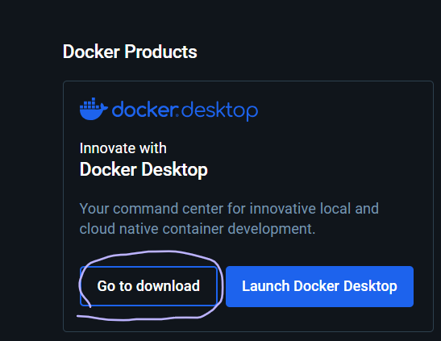

Git is a popular source code management tool. And GitHub is a cloud-based platform that provides services to store source code. And together it enables us to work in a collaborative manner.

In the coming session we will do some hands-on session to create new git repositories in GitHub and then use our local git setup to download and make changes.

We will understand how multiple developers can work on the same project and make changes.